EXP 19

AIM: Design TM using simulator to perform addition of ‘aa’ and ‘aaa’

INPUT:

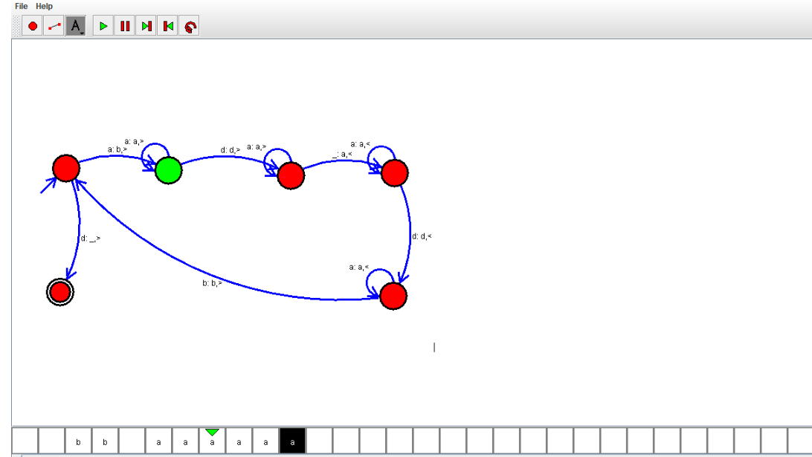

OUTPUT:



RESULT: Design TM using simulator to perform addition of ‘aa’ and ‘aaa’ is successfully verified